**Analyzing Olist E-commerce Sales Performance**

## **Introduction:**

This project involves exploring and visualizing data from Olist, an e-commerce platform that links sellers with customers seeking to buy their products or services. The dataset is provided publicly to help data analysts gain insights into the e-commerce market and uncover avenues for growth and improvement.

**Utilized Power BI for:**

1. Data cleaning and validation using Power Query
2. Data modeling
3. Visualizing data
4. Implementing DAX concepts such as calculated measures and columns
5. Applying filters and slicers
6. Implementing drill-through functionality

The provided business inquiries aim to provide the Olist team with enhanced insights into their e-commerce platform and identify opportunities for growth. My objective is to furnish responses to these inquiries, offering valuable insights that will drive business expansion for the Olist e-commerce platform.

**Business Questions:**

1- What is the total revenue generated by Olist, and how has it trended over a period of time?

2- How does the number of orders placed on Olist vary on a monthly or seasonal basis?

3- What product categories are the most popular on Olist, and how do their sales compare to each other?

4- How does the average order value (AOV) on Olist vary based on product category or payment method?

5- How many active sellers are currently operating on Olist, and how has this number changed over time?

6- What is the distribution of seller ratings on Olist, and how does this impact sales performance?

7- How many customers engage in repeat purchases on Olist, and what percentage of total sales do they contribute?

8- What is the average customer rating for products on Olist, and how does it correlate with sales?

9- How does the average order cancellation rate on Olist affect seller performance?

10- What are the top-selling products on Olist, and how have their sales trends evolved over time?

11- What payment methods do Olist customers commonly use, and how does this usage differ by product category or geographic region?

12- How do customer reviews and ratings influence sales and product performance on Olist?

13- Which product categories yield the highest profit margins, and how can profitability within these categories be enhanced?

14- How does Olist's marketing expenditure and channel mix impact sales and customer acquisition costs, and how can the marketing strategy be optimized for improved ROI?

15- Conduct an analysis of customer retention rates based on geolocations with high customer density.

## **Data Transformation in Power Query:**

The dataset was imported into Power BI's Power Query for comprehensive data validation and cleaning. Initially, column profiling settings were adjusted to analyze the entire dataset. 'Column quality', 'Column profile', and 'Column distribution' options were enabled to obtain summary information for each table column. This facilitated effective validation and transformation where necessary. The cleaning process was conducted per table, focusing on enhancing data quality and integrity to ensure suitability for analysis and decision-making.

**Below** is the outlined summary of the transformation process that was carried out:

* The "Use First row as header" action was applied to columns where first rows were not headers.
* Column datatypes were validated appropriately.
* Creating ‘DimDate’ table using M code to integrate all date in ‘DimDate’.
* Text columns were formatted to be in Proper case were applicable.
* The columns with date and time together were split to extract date part and for ease of date-based analysis.
* Duplicates were removed where applicable.

## **Data Modelling:**

Normalized data from multiple tables requires a Star Schema model. The model includes one Fact table, Olist_Order_items_dataset, containing granular data for analysis with quantitative and numeric measures.

The Factless fact table, Olist_Order_items_dataset, tracks sales/purchase events using dates and foreign keys for dimension references. It serves as a bridge table to establish relationships between dimensions.

Six dimension tables (Olist_customers_dataset, Olist_geolocation_dataset, Olist_order_payments_dataset, Olist_order_reviews_dataset, Olist_products_dataset, Olist_sellers_dataser, product_category_name_translation) hold attributes describing the fact tables' data. They serve to constrain/filter queries on the fact tables, limiting inquiries to primary data.

A date dimension table ‘DimDate’ was then created in power query using M Query language.

Date dimension was created to facilitate flexible time-based analysis and hierarchical relationships at different granular levels (e.g., day, week, month). This enables drill-down capabilities in visualizations for deeper insights.

The 7 dimension tables were then modeled/connected to the fact tables using Primary and foreign keys, that is, the common columns between them.

The relationships between the tables are mainly one-to-many/many-to-one, except for the one between the customer and order table, which is a one-to-one relationship.

## **Data Exploration and Visualization in Power BI:**

DAX concepts, visuals/charts, drill-throughs, and filters/slicers in Power BI were utilized to achieve these objectives.

**1- What is the total revenue generated by Olist, and how has it trended over a period of time?**

Total revenue for Olist E-commerce Store from September 2016 to September 2018 amounted to $15,422,461.77 **(15.42million Dollar)**. This was computed by summing the Payment_value for delivered orders using a DAX calculated measure.

Revenue was calculated from orders marked as "delivered," reflecting actual revenue generated. Over the 3-year period, revenue showed steady growth, with the largest increase observed from 2016 to 2017.

|  |
| --- |
| [A Power BI visual](https://app.powerbi.com/MobileRedirect.html?action=OpenReport&reportObjectId=b3b563b2-c43d-4f2c-9683-2d2b5d22f6b1&ctid=df8679cd-a80e-45d8-99ac-c83ed7ff95a0&reportPage=ReportSection&pbi_source=copyvisualimage) |
|  |

|  |
| --- |
|  |
|  |

The revenue trend showed consistent growth over time, with a notable dip in September. Further analysis revealed that most sales occurred between October 2016 and August 2018, with September records primarily from 2017. A significant revenue spike was observed on November 24, 2017, attributed to Black Friday sales, indicating a surge in customer purchases due to highly discounted rates.

**2- How does the number of orders placed on Olist vary on a monthly or seasonal basis?**

|  |
| --- |
| [A Power BI visual](https://app.powerbi.com/MobileRedirect.html?action=OpenReport&reportObjectId=b3b563b2-c43d-4f2c-9683-2d2b5d22f6b1&ctid=df8679cd-a80e-45d8-99ac-c83ed7ff95a0&reportPage=ReportSection&pbi_source=copyvisualimage) |
|  |

Out of 99,441 orders placed on Olist e-commerce store, 96,478 were delivered, contributing to the revenue.

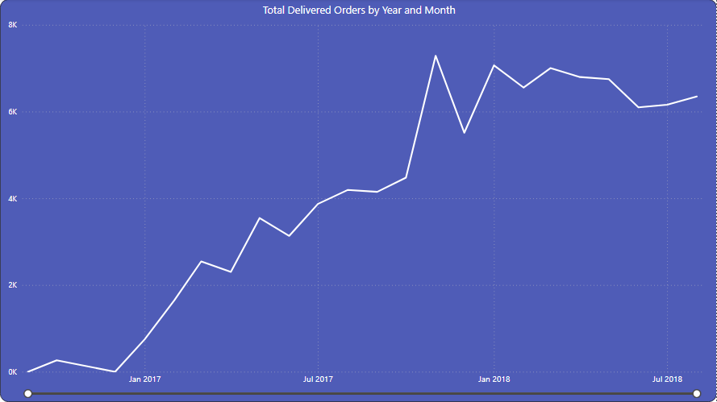

Over time, there's been a noticeable rise in orders, aligning with the trend seen in total revenue. November 2017 stood out with the highest number of successful orders (7289), likely influenced by the Black Friday event on November 24, 2017.

**3- What product categories are the most popular on Olist, and how do their sales compare to each other?**

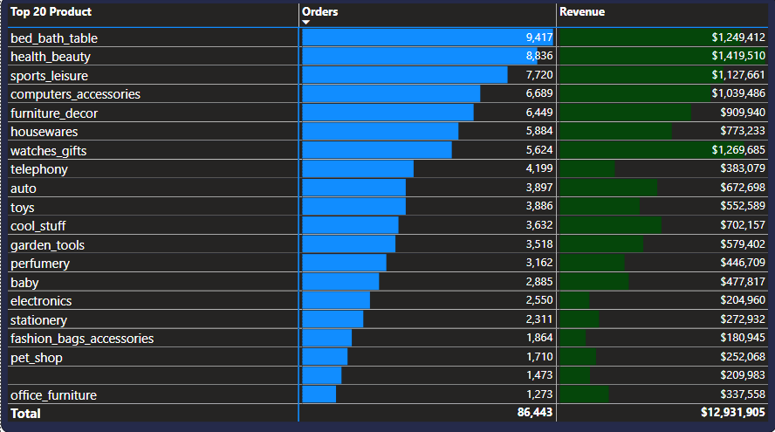

However, in terms of sales volume, the **bed_bath_table** product category has the highest sales volume of $1,249,412 followed by **Health_Beauty** category ($1,419,509) and sports_leisure ($1,127,661) being the 3rd in highest sales volume.

**4- How does the average order value (AOV) on Olist vary based on product category or payment method?**

|  |
| --- |
| [A Power BI visual](https://app.powerbi.com/MobileRedirect.html?action=OpenReport&reportObjectId=b3b563b2-c43d-4f2c-9683-2d2b5d22f6b1&ctid=df8679cd-a80e-45d8-99ac-c83ed7ff95a0&reportPage=ReportSection&pbi_source=copyvisualimage) |
|  |

From the analysis, although the most popular product didn't yield the highest sales volume, we delve deeper to assess the average monetary value per order, known as the Average Order Value (AOV), and its variance across product categories and payment methods. The AOV for the Olist store stands at $159.85, calculated by dividing the total revenue by the number of delivered orders.

From investigating the AOV across product categories and payment methods, we find that Computers have the highest average order value among product categories, while Credit card payments exhibit the highest AOV among payment types.

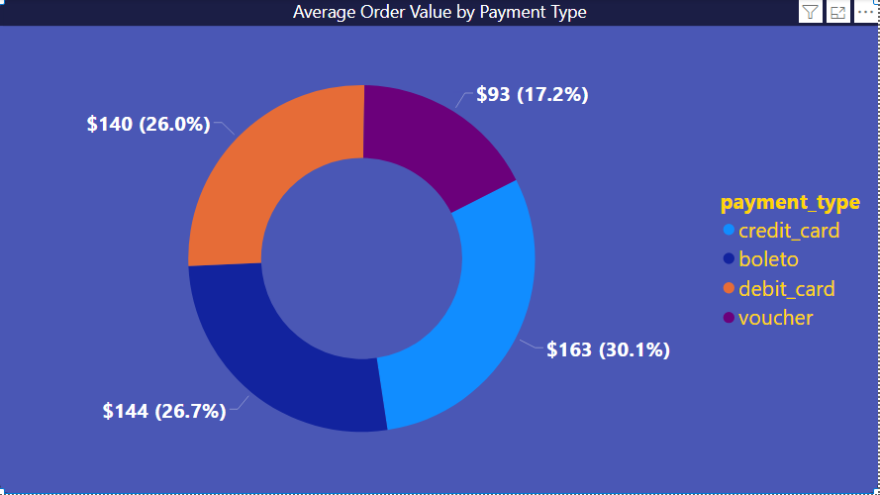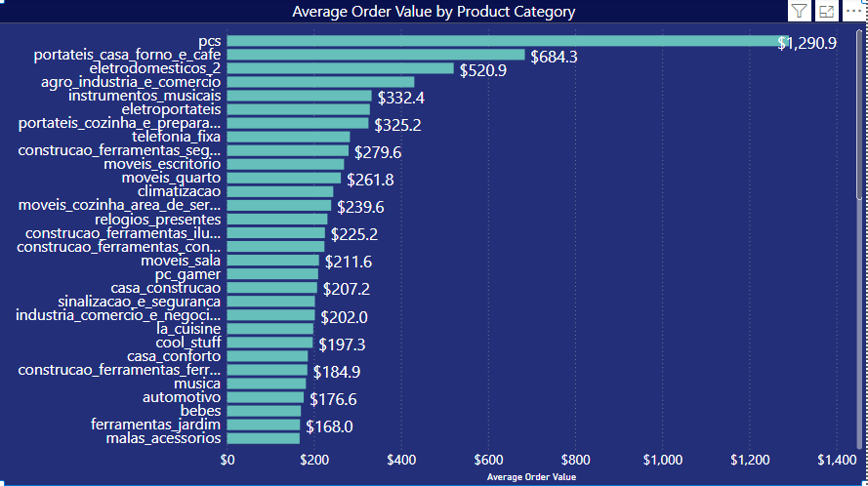

**5- How many active sellers are currently operating on Olist, and how has this number changed over time?**

For a merchant-customer platform, tracking seller activity is crucial. An active seller is defined as one who completes at least one successful sale within 30 days, where success is measured by order delivery.

|  |
| --- |
| [A Power BI visual](https://app.powerbi.com/MobileRedirect.html?action=OpenReport&reportObjectId=b3b563b2-c43d-4f2c-9683-2d2b5d22f6b1&ctid=df8679cd-a80e-45d8-99ac-c83ed7ff95a0&reportPage=ReportSection94b1c963568495e08e26&pbi_source=copyvisualimage) |
|  |

The measure tallies unique seller IDs in 'olist_orders_items' where orders are "delivered" and purchase dates fall within the last 30 days from the latest purchase date, yielding 2,970 active sellers.

Going further, I evaluated the variation of Active sellers on the platform over time and observed that there has been a consistent increase in active sellers across the years and months.

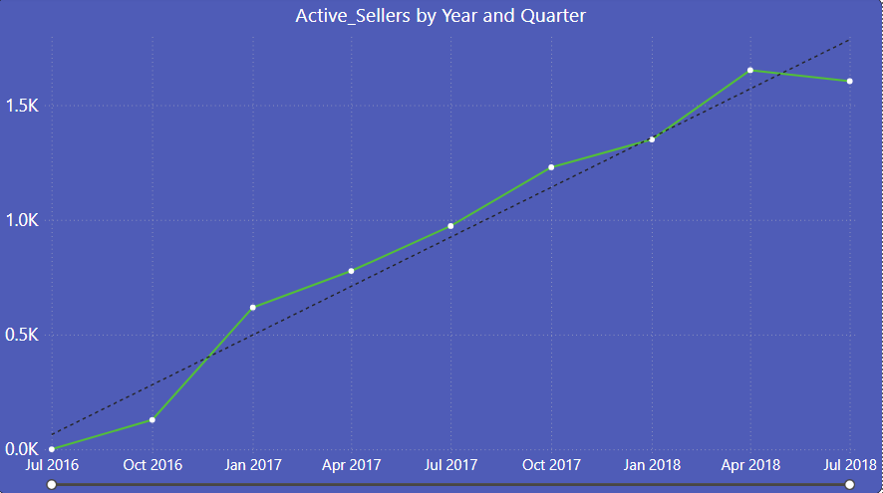

Analyzing the fluctuation of active sellers on the platform over time, I noticed a steady rise in the number of active sellers throughout the years and months.

**6- What is the distribution of seller ratings on Olist, and how does this impact sales performance?**

Having determined the count of active sellers on Olist, the next step is to assess their performance based on customer ratings. For this, I formulated a calculated measure to derive the average customer rating from the review scores.

We further analyzed sales performance by assessing total revenue per seller alongside their average rating. The visualization revealed a positive correlation between seller ratings and sales outcomes, indicating that sellers with higher ratings achieve greater sales. The top-performing seller boasted an average rating of 4.12.

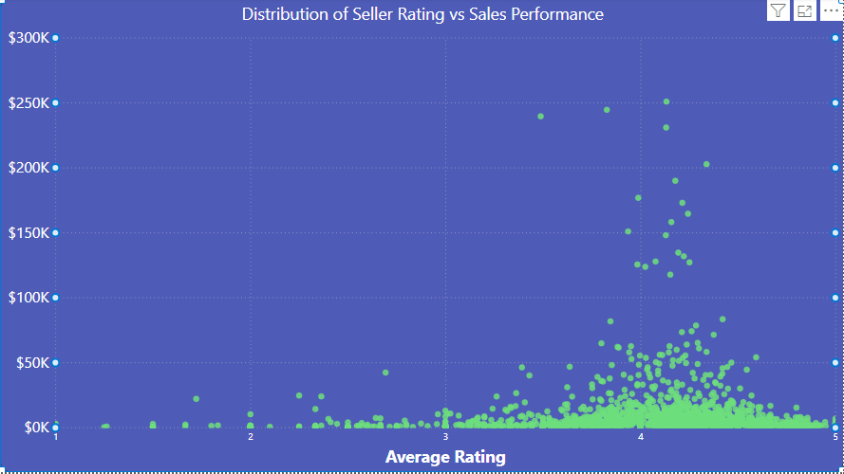

**7- How many customers engage in repeat purchases on Olist, and what percentage of total sales do they contribute?**

After reviewing the previous visualization, it was evident that over 50% of sellers received high ratings. We aim to assess whether this satisfaction translates into repeat purchases by customers. To achieve this, I created a calculated column to identify repeat purchases based on customers' unique IDs.

The formula determines if a customer has made multiple purchases by comparing the count of 'order_id' in the olist_orders table to 1. If greater than 1, it returns 1, indicating repeat purchases; otherwise, it returns 0 for a single purchase. Subsequently, a calculated measure was created to count customers with repeat purchases

Repeat Purchase Customers measure

|  |
| --- |
| [A Power BI visual](https://app.powerbi.com/MobileRedirect.html?action=OpenReport&reportObjectId=b3b563b2-c43d-4f2c-9683-2d2b5d22f6b1&ctid=df8679cd-a80e-45d8-99ac-c83ed7ff95a0&reportPage=ReportSectionbf8e84c78210e594bc59&pbi_source=copyvisualimage) |
|  |

The measure computes the unique count of customers with repeat purchases, filtering orders with a status of 'delivered'. Focusing solely on delivered orders ensures accuracy in identifying true repeat purchases. The analysis reveals that 2,979 customers made repeat purchases.

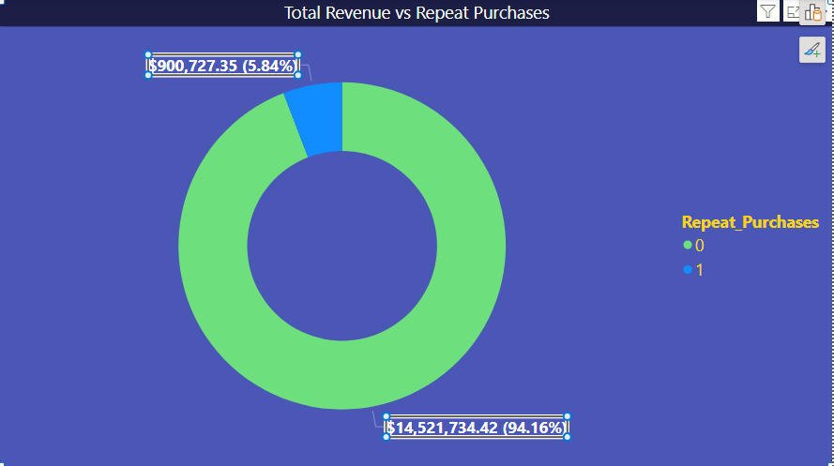  
Based on the visual above we can see that repeat purchases accounted for 5.84% ($900,727) of the total revenue.

**8- What is the average customer rating for products on Olist, and how does it correlate with sales?**

From our analysis, it's evident that less than 5% of customers engaged in repeat purchases. To understand this behavior, we investigated the influence of product ratings on sales performance. The average rating, calculated at 4.09 on a 5-point scale, indicates overall customer satisfaction with the products.

|  |
| --- |
| [A Power BI visual](https://app.powerbi.com/MobileRedirect.html?action=OpenReport&reportObjectId=b3b563b2-c43d-4f2c-9683-2d2b5d22f6b1&ctid=df8679cd-a80e-45d8-99ac-c83ed7ff95a0&reportPage=ReportSection94b1c963568495e08e26&pbi_source=copyvisualimage) |
|  |

How does this impact the sales performance?

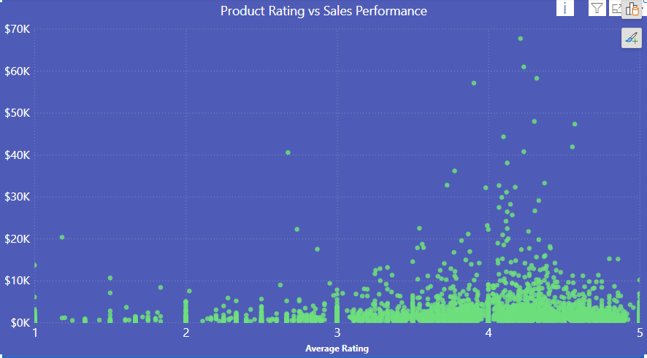

According to the visual presented, the product boasting the highest sales revenue possesses a rating of 4.21, surpassing the average rating across all products.

**9- How does the average order cancellation rate on Olist affect seller performance?**

As we delve deeper into understanding Olist customers' behavior, including repeat purchases and seller/product ratings, we now shift our focus to cancelled orders and their impact on seller performance. Understanding the factors influencing cancellations is crucial. Using the measure below, the average order cancellation rate was calculated at 0.63%.

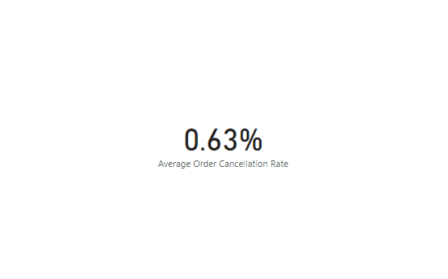

Next, I analyzed the average order cancellation rate for sellers based on various factors such as the minimum price of the product, total revenue, average rating, and number of orders. Utilizing Power BI's AI feature, I employed the Key Influencers visual for this analysis. The visual indicates that as the average rating decreases, the average order cancellation rate increases, and vice versa. Similarly, as the minimum price of a seller decreases, it is likely that the average order cancellation rate will also decrease, and vice versa.

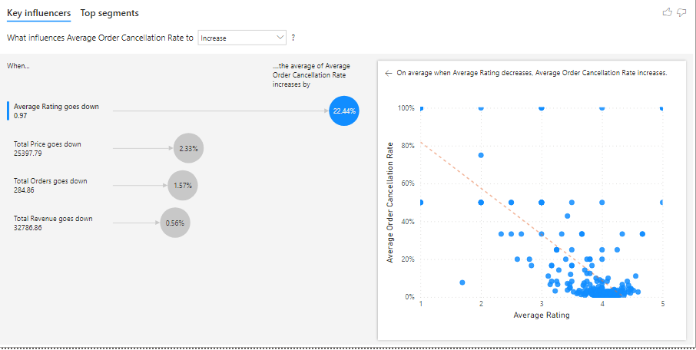

Moreover, a rise in the average order cancellation rate leads to a decrease in the number of orders sold and total revenue, whereas a decrease in the average order cancellation rate correlates with an increase in the number of orders sold and total revenue.

Moreover, a rise in the average order cancellation rate leads to a decrease in the number of orders sold and total revenue, whereas a decrease in the average order cancellation rate correlates with an increase in the number of orders sold and total revenue.

There is therefore need to mitigate the factors that may likely increase average order cancellation rate.

**10- What are the top-selling products on Olist, and how have their sales trends evolved over time?**

Now, delving into the product landscape of Olist, we'll examine the top 10 selling products and how their sales trends have evolved over time. Utilizing the decomposition tree visual, we analyzed the product categories' sales performance in terms of total revenue across different years.

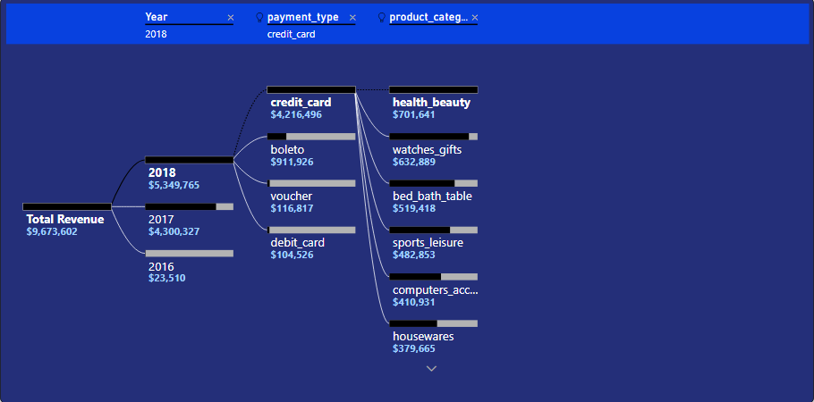

The visualization illustrates that the top-selling product category varied over the years. In 2016, Furniture_Decor led the sales, followed by Bed_Bath_Table in 2017, and Health_Beauty in 2018. Nonetheless, Health_Beauty consistently ranked among the top three selling categories throughout the three-year period.

**11- What payment methods do Olist customers commonly use, and how does this usage differ by product category or geographic region?**

The below visualization indicates that the most prevalent payment method is Credit card, while the least common is Debit card. Further exploration across locations and products reveals a consistent pattern, with Credit card being the most used method followed by Boleto.

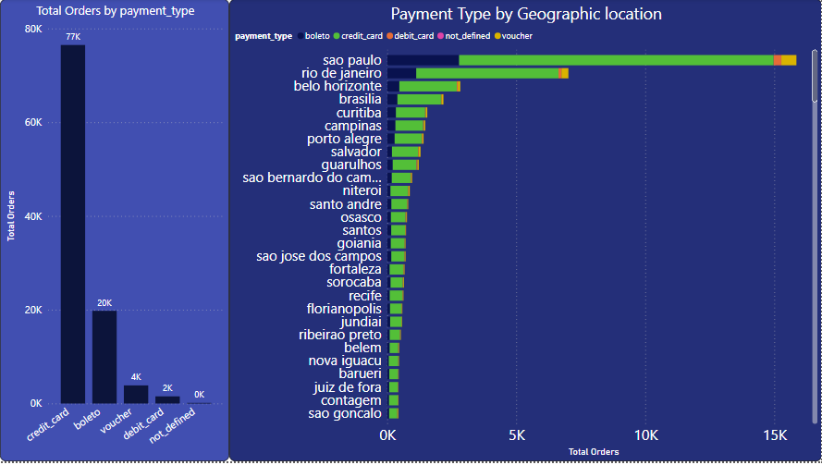

**12- How do customer reviews and ratings influence sales and product performance on Olist?**

As noted in previous analyses for questions similar to Q6 and Q8, it's evident that sellers and products achieving the highest revenue/sales performance typically boast ratings exceeding the average rating of 4.07.

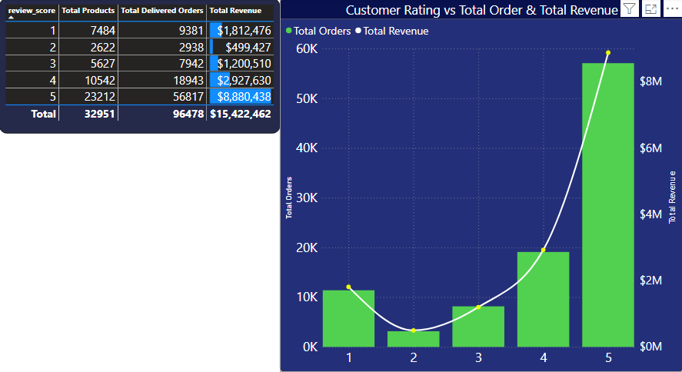

Upon further exploration, it's evident from the visual provided that products with an average review score of "1" outperformed those with a score of "2" in terms of revenue. This discrepancy could be attributed to the higher volume of products sold with a "1" rating, approximately three times more than those with a "2" rating. Consequently, we observe a positive correlation between rating and total revenue, where an increase in rating leads to higher revenue.

**13- Which product categories yield the highest profit margins, and how can profitability within these categories be enhanced?**

Since Olist operates as a for-profit organization, it's crucial to identify the most profitable product categories. To achieve this, we assess the profit margin across different categories. Although the dataset lacks cost price information, we compute the gross profit margin by subtracting the cost price from the selling price (price), dividing by the total revenue, and multiplying by 100 (percent). Below is the DAX measure used to calculate the gross profit margin.

The resulting Gross Profit Margin computed is **85.73%**.

|  |
| --- |
| [A Power BI visual](https://app.powerbi.com/MobileRedirect.html?action=OpenReport&reportObjectId=b3b563b2-c43d-4f2c-9683-2d2b5d22f6b1&ctid=df8679cd-a80e-45d8-99ac-c83ed7ff95a0&reportPage=ReportSection384eec0a0e010400a606&pbi_source=copyvisualimage) |
|  |

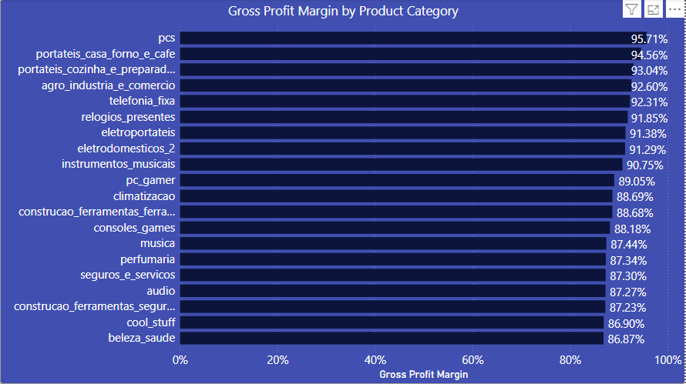

Upon exploring different product categories, it's evident that "Computers" boasts the highest gross profit margin at 95.71%, followed by "Small_Appliances_Home_Oven_And_Coffee" at 94.56%, and "Portable_kitchen_and_food_preparators" at 93.04%. This observation is depicted in the visual below.

**How can profitability within these categories be enhanced?**

To enhance profitability across categories, Olist can bolster seller relationships through negotiations for benefits like bulk discounts and exclusive arrangements. By refining pricing strategies collaboratively, they ensure competitiveness without compromising revenue. Implementing tiered pricing based on quantity or other factors further optimizes profitability and incentivizes strategic product offerings.

Additionally, Olist can employ cross-selling and upselling tactics to prompt customers to buy more or upgrade their purchases. Leveraging AI and data analytics enables personalized recommendations tailored to individual preferences and buying behaviors, thereby boosting average order value and driving profitability. Our analysis reveals a correlation between the category with the highest profit margin and the highest average order value.

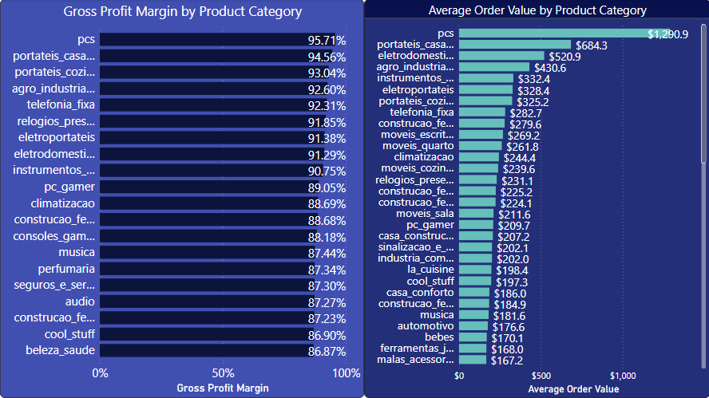

Additionally, they can consider phasing out or re-evaluating low-margin products that are not contributing significantly to profitability.

**14- How does Olist's marketing expenditure and channel mix impact sales and customer acquisition costs, and how can the marketing strategy be optimized for improved ROI?**

Marketing spend refers to the financial investment in promotional activities, directly shaping the reach and effectiveness of Olist's marketing efforts.

Channel mix encompasses the distribution of marketing endeavors across various platforms like social media, email marketing, and influencer partnerships. Diversifying the channel mix enhances the potential to reach a broader audience and convert leads into customers, thereby impacting sales outcomes.

Therefore, augmenting marketing spend by allocating adequate funds to a diverse channel mix can potentially elevate brand visibility, foster new customer acquisition, and ultimately drive sales. However, it's crucial for the business to prioritize channels with high lead conversion rates while maintaining a balance between the marketing budget and ROI.

Regarding Customer Acquisition Costs (CAC), which represents the expenses associated with acquiring new customers, Olist can evaluate the cost-effectiveness of each acquisition channel by analyzing metrics such as cost per lead, cost per customer, and customer lifetime value (CLTV). If the CAC proves to be excessively high, adjustments can be made to optimize the strategy and minimize acquisition costs.

To refine its marketing strategy and enhance ROI, Olist can leverage data analytics to gain insights into customer behavior, preferences, and purchasing patterns. This data-driven approach enables Olist to identify high-performing channels, refine the channel mix as needed, and allocate resources effectively.

Additionally, Olist can implement targeted marketing campaigns tailored to specific customer segments based on demographics, interests, and buying habits. By customizing messaging and promotional offers, Olist can enhance customer engagement, increase lead conversion rates, and drive sales growth.

**15- Conduct an analysis of customer retention rates based on geolocations with high customer density.**

Concluding our analysis, we'll examine the geographical distribution of Olist's customer base. Over the three-year period, there were a total of 99,441 customers. Among regions with dense customer populations, São Paulo, Rio de Janeiro, and Minas Gerais emerge as the top three locations.

|  |
| --- |
| [A Power BI visual](https://app.powerbi.com/MobileRedirect.html?action=OpenReport&reportObjectId=b3b563b2-c43d-4f2c-9683-2d2b5d22f6b1&ctid=df8679cd-a80e-45d8-99ac-c83ed7ff95a0&reportPage=ReportSectionbf8e84c78210e594bc59&pbi_source=copyvisualimage) |
|  |

**But does High Customer density equate high Customer retention rate?**

To check for this, the overall Customer retention rate was computed using the DAX measure. The results was 3.0

|  |
| --- |
| [A Power BI visual](https://app.powerbi.com/MobileRedirect.html?action=OpenReport&reportObjectId=b3b563b2-c43d-4f2c-9683-2d2b5d22f6b1&ctid=df8679cd-a80e-45d8-99ac-c83ed7ff95a0&reportPage=ReportSectionbf8e84c78210e594bc59&pbi_source=copyvisualimage) |
|  |

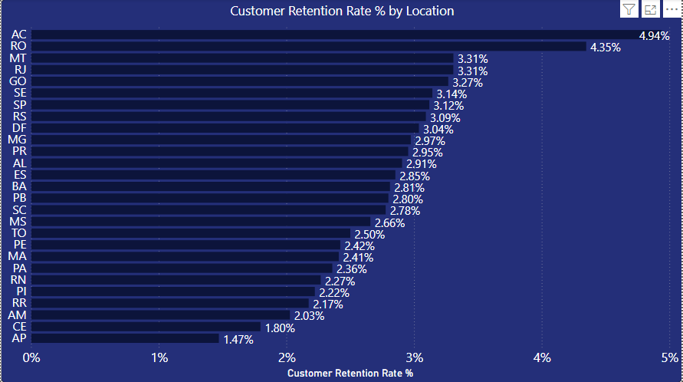

Diving deeper into the analysis, we find that despite being among the regions with the lowest customer density, Acre exhibits the highest customer retention rate. Following closely are Rondonia and Mato Grosso, which also demonstrate notable levels of customer retention.

**Critical Findings.**

Over the 3-year span, Olist E-commerce Store amassed a substantial revenue of $15,422,461, attributed to various factors like diverse product offerings, competitive pricing, and user-friendly interface, fostering customer retention.

Notably, in November 2017, the Black Friday sales contributed significantly, accounting for 15.19% of the total revenue for the month.

Olist boasts a commendable order delivery success rate of 97%, underscoring its robust logistics and fulfillment infrastructure.

Interestingly, the top-selling product categories didn't consistently correlate with the highest sales volumes, suggesting other factors like pricing and product quality at play.

The platform's Average Order Value (AOV) stands at $159.85, indicating a preference for higher-priced items among customers.

With 96% active sellers, Olist provides a conducive environment for merchants, leading to a steady rise in seller participation over time.

Repeat purchases contribute significantly, accounting for 5.84% of total revenue, indicating a loyal customer base.

Credit cards dominate payment methods, followed by Boletos, with debit cards being the least preferred option.

High-performing products and sellers generally boast ratings above the platform's average of 4.07.

Despite a low cancellation rate of 0.63%, cancelled orders incurred a loss of $143,255, influenced by customer ratings and seller pricing.

Sales trends across product categories remain competitive, with each year witnessing a new category taking the lead.

The gross profit margin of 85.73% indicates healthy profitability, with categories like Computers leading in both order value and profit margin.

Geolocation analysis reveals Sao Paulo as the hub of customer density, while Acre demonstrates remarkable customer retention, despite being less densely populated.

## **Recommendations:**

Olist can enhance customer engagement and revenue by introducing seasonal or quarterly promotional events similar to the successful "Black Friday" sales. This strategy can stimulate product purchases and drive overall sales growth.

Maintaining superior product quality and competitive pricing is crucial to reducing order cancellations, enhancing customer satisfaction, and ultimately increasing revenue.

Implementing loyalty programs, such as exclusive discounts for repeat customers and free shipping to targeted regions like Sao Paulo and Acre, can foster repeat purchases, improve customer retention, and attract new customers.

With its impressive revenue and profit margin, Olist has established itself as a profitable player in the online market. Consideration should be given to investing in new products and services and expanding into untapped markets to fuel further growth and maintain leadership in the Brazilian e-commerce landscape.

**Conclusion:**

1. By responding to the descriptive analytical, and business questions, I have achieved the goal of helping Olist gain better insights into their e-commerce platform and know how to optimize available opportunities for growth.
2. Make a customer segmentation Details Page
3. The forecast for product category sales over the next six months will provide valuable insights into future revenue trends and market demand in Sales Predication page

**I eagerly await your honest feedback, constructive critiques, and valuable insights.**

**Name: Yousef Ahmed**

**Thank you for your time.**